**Check cluster-based calculation process**

$${WeightedTime}_{pikj}= \sum_{j∈center}{{Time}_{mtkj}*{Trips}_{pimkj}/\sum_{j∈center}{{Trips}_{pimkj}}}$$

$${WeightedDistance}_{pikj}= \sum_{j∈center}{{Distance}_{mtkj}*{Trips}_{pimkj}/\sum_{j∈center}{{Trips}_{pimkj}}}$$

Because travel time does not differ by income group, the weighted time depends on the **distribution** of trips among TAZs of centers.

Trip distribution

**Table 1 Ratio between trips of different income groups**

|  |  |  |  |
| --- | --- | --- | --- |
|  | Ratio between income groups | | |
| Purpose | highInc & midInc | highInc & midInc | midInc & lowInc |
| HBW | different | different | different |
| HBS | same | different | different |
| HBR | same | same | same |
| HBO | same | same | same |

HBW

For each production TAZ, the ratio between trips by different groups differ by destination TAZs of HBW centers.

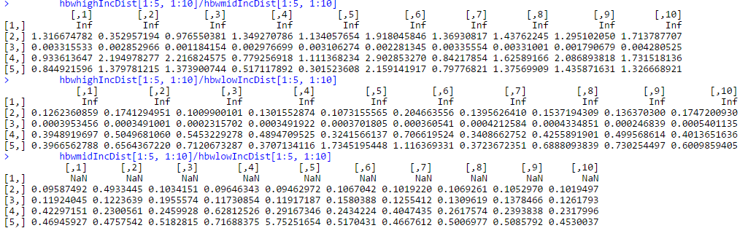

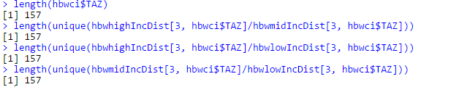

**HBS**

For each production TAZ, the ratio between trips by highInc group and midInc does not differ by destination TAZ of HBS centers, but the ratio between trips by midInc and lowInc, and ratio between trips by highInc and lowInc differ by destination TAZ of HBS centers.

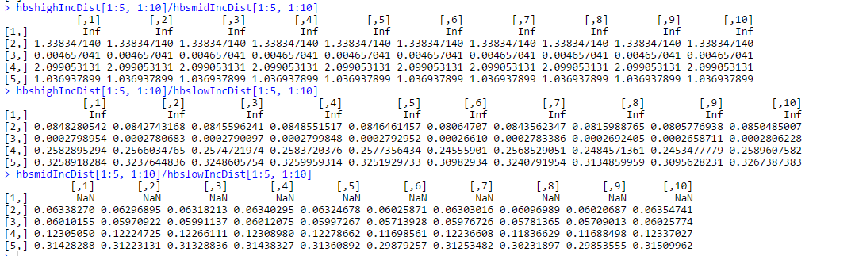

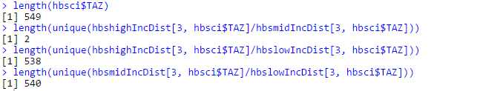



HBR

For each production TAZ, the ratio between trips by different income groups does not differ by destination TAZs of HBR centers.

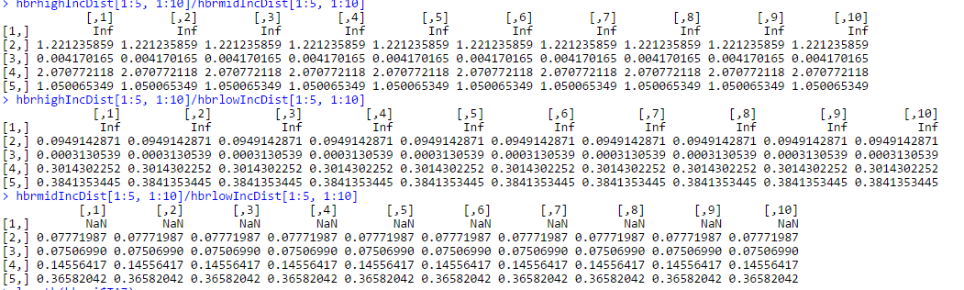

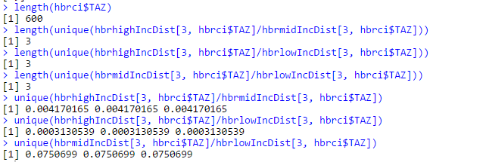

HBO

For each production TAZ, the ratio between trips by different income groups does not differ by destination TAZs of HBR centers.

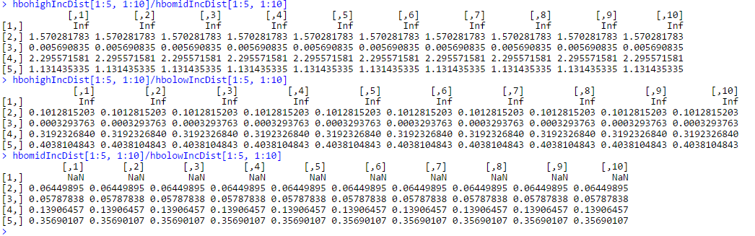

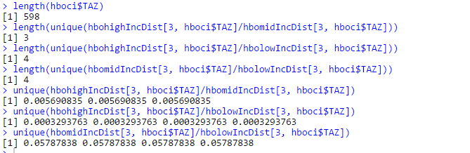

ExpUtility

Only utility of HBW differ by income group.

HBW

For HBW utility, the utility does not differ by income groups except busWalk mode.

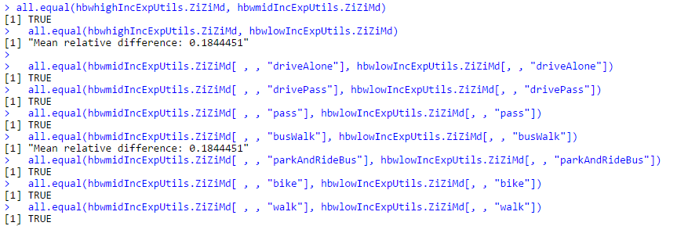

The formulas for calculating utility of busWalk mode differ by income groups. This is maybe input error.

**busWalklowInc**

" hbwPeakFactor * (0 + -0.03608 * ivTimepeak + -0.09956 * walkTimepeak + -0.05760 * **waitTimeApeak** + -0.04002* **waitTimeBpeak** + -0.3 * boardingspeak) + (1 - hbwPeakFactor) * (0 + -0.03608 * ivTimeoffPeak + -0.09956 * walkTimeoffPeak + -0.05760 * waitTimeAoffPeak + -0.04002 * waitTimeBoffPeak + -0.3 * boardingsoffPeak)"

**busWalkmidInc**

" hbwPeakFactor * (0 + -0.03608 * ivTimepeak + -0.09956 * walkTimepeak + -0.05760 * **waitTimeAoffPeak** + -0.04002 * **waitTimeBoffPeak** + -0.3 * boardingspeak) + (1 - hbwPeakFactor) * (0 + -0.03608 * ivTimeoffPeak + -0.09956 * walkTimeoffPeak + -0.05760 * waitTimeAoffPeak + -0.04002 * waitTimeBoffPeak + -0.3 * boardingsoffPeak)"

**busWalkhighInc**

" hbwPeakFactor * (0 + -0.03608 * ivTimepeak + -0.09956 * walkTimepeak + -0.05760 * **waitTimeAoffPeak** + -0.04002 * **waitTimeBoffPeak** + -0.3 * boardingspeak) + (1 - hbwPeakFactor) * (0 + -0.03608 * ivTimeoffPeak + -0.09956 * walkTimeoffPeak + -0.05760 * waitTimeAoffPeak + -0.04002 * waitTimeBoffPeak + -0.3 * boardingsoffPeak)"

HBS



HBR

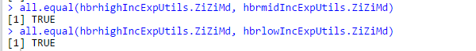

HBO



Aggregate cost by mode and time of factor

$${TotTrips}_{pimk}= \sum_{j}{{Trips}_{pimkj}}$$

$${FullCost}_{pimk}= {FullCostPeak}_{pimk}*{TFactor}_{pm}+{FullCostOffPeak}_{pimk}*(1-{TFactor}_{pm})$$

$${AggCost}_{pitk}={(TotTrips}_{pimtk}*{FullCost}_{pimk}) /\sum_{m}{{TotTrips}_{pimk}}$$

HBW

For HBW purpose, distance and time cost differ by income group.



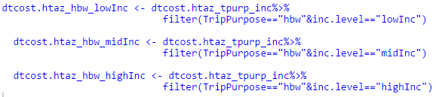

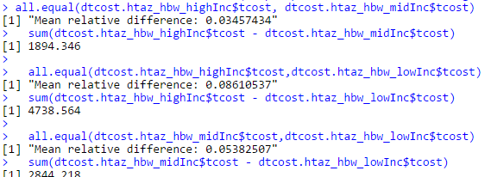

HBS

For HBS purpose, distance and time costs for highInc and midInc groups are the same, but the distance and time cost of lowInc group is different from that of highInc and lowInc groups.

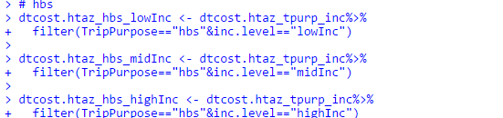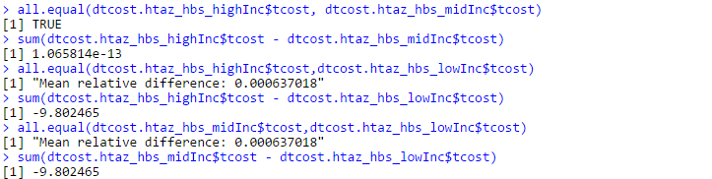

HBR

For HBR distance and time cost does not differ by income groups.

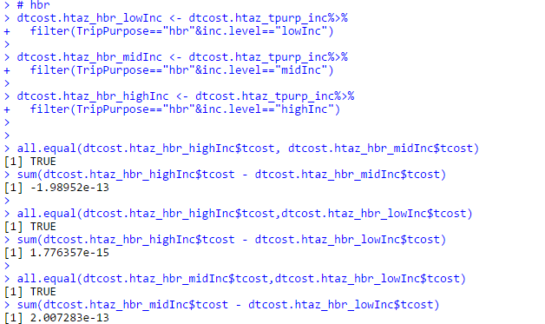

HBO

For HBO distance and time cost does not differ by income groups.

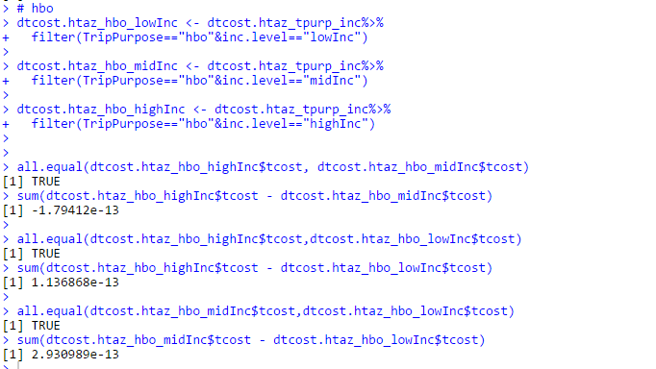

Cost weighted by trips/hhs of TAZ

The difference of cost between income groups is caused by weighting with trips/hhs.

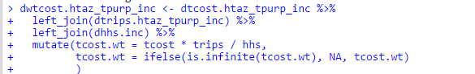

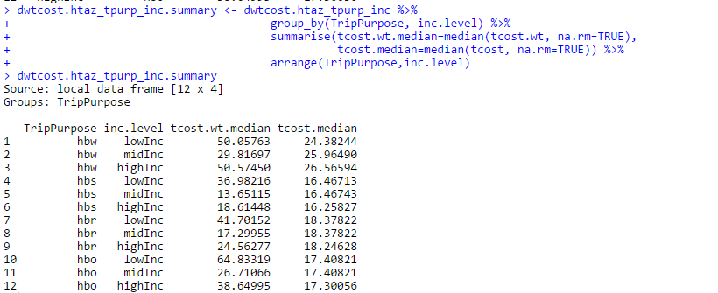

Do not weight by trips/hhs of TAZ

If do not weight by trips/hhs of TAZ, the result of HBW is a little more similar to OHAS result.

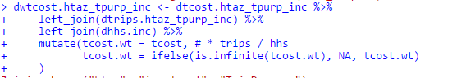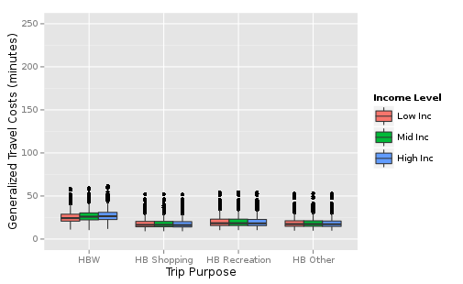

Use median(tcost) to aggragate

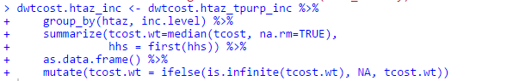

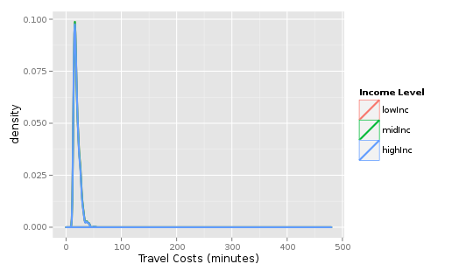

Use trip to aggregate

